MineSweeper Documentation

# Created by: Maanav Dalal Date: July 26th 2017

Installation Guide

1.Ensure that your PC has at least:

* 125MB Storage space (124 for JRE, 0.25 for program)
* 128MB RAM
* Pentium 2 266 MHz Processor (1998)

2.Install the latest version of the JRE (if you don't have it) at:

<http://bit.ly/1r2AXKi> (choose your operating system)

3.Extract the files from the zip

1. Use windows explorer to double-click the .zip file named MineSweeper.zip
2. Drag the "U4_MineSweeper_Maanav" folder to your desired directory
3. Wait for the extraction to finish.

4. That's all!

To play, double-click the "U4_MineSweeper_Maanav.jar" file.

Tutorials

Instructions are available both inside the game and in this manual.

To access them in game, either use the top panel and click

Instructions > General "Instructions" button CTRL+I

General instructions:

In each game, you see a board of squares. Some contain bombs, others don't. If you click a square with a bomb, you lose. The objective of the game is to isolate all squares containing bombs, and click all squares that do not have bombs. Clicking a square that doesn't have a bomb reveals the number of adjacent squares that have bombs. Using this information, as well as some guesswork and understanding of probability, try to avoid the bombs.

Flagging instructions:

To flag a square as a visual marker for a mine, right click it. Be careful though, since you can still left click it! Accessed via CTRL+F.

Gameplay:

To play the game, just run the .jar file and choose either beginner orintermediate mode. The game works just as the instructions say. You can flag squares you think are mines with right click, and left click a square to choose it.

Reset:

You will be forced to reset the game upon losing, but can also reset at any time via the big "Reset" button at the top of the screen. This option mayalso be found under the top panel at Options > Reset Game, or accessed via the shortcut CTRL+R.

New Game:

CTRL+N can be used to go back to the splash screen and start a new game, and this option may also be found under the top panel at Options > New Game.

EXIT GAME:

To exit the game, the top right X button can be used at any time. Additionally, there is an “Exit” button on the intro screen.

**Reference Manual**

*License information:*

Licensed to Shreyas Krishna Prasad, Math Teacher @ Harvard University.

*Program’s Purpose:*

To aid Professor Prasad in teaching students at Harvard University probability as well as strategy. This simple minesweeper game is intuitive, easy to play, and easy to understand. It will take less than 10 minutes for any student to understand it, and modifying it to the user’s criteria requires nothing more than a text editor.

*Features List:*

Expansion method (somewhat recursive)

Just like a normal minesweeper, there is an included method which expands the squares that are adjacent to the square you clicked (provided it has no adjacent mines) and continues expanding until there are no adjacent squares that have no mines in them. Although this method is not directly recursive, it does call the method that runs it and will keep in turn calling itself until there are no longer adjacent empty squares.

Colour Scheme

The following colour scheme was used for an appealing user experience:

Difficulty

The difficulty is determined by the beginner/ intermediate option, but if the user wants a challenge, they can change the “difficulty” variable within the game’s code.

Flagging

Although in the current iteration of the game, you cannot remove flags, you may right click the field to flag it with a place you think that a mine is. At that time, the counter for mines will drop by 1 to indicate to the user that there should be one less mine. You can still left click the flag to reveal it, however.

Game Screens

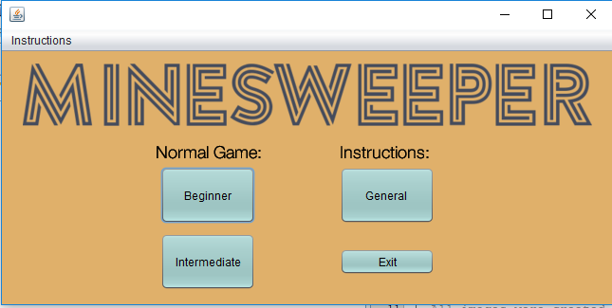 Intro: The intro screen is simple and leaves the user few options – start a new game as a beginner or intermediate player, or read the instructions. They can also close the game at this point

9x9: By choosing the beginner mode, you can choose a 9 by 9 grid with 10 mines:

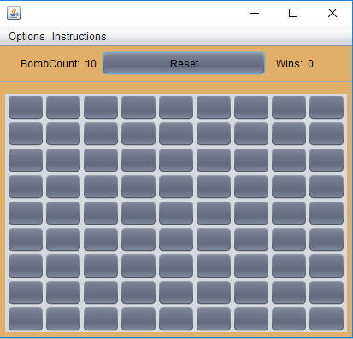

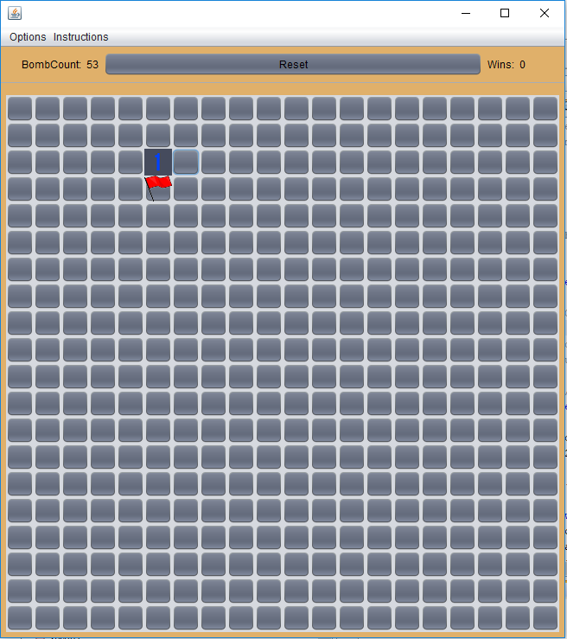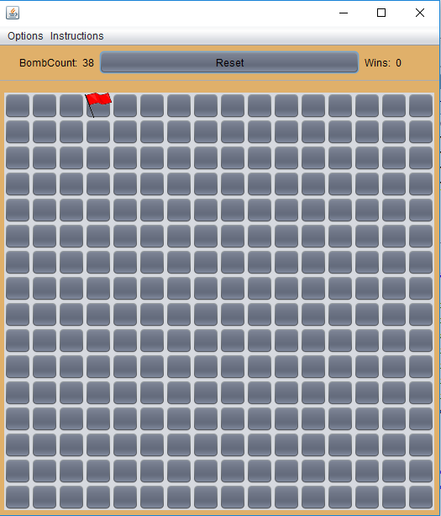16x16: The intermediate mode will have a 16x16 grid, and 39 mines:

Expandability to a custom square grid:

If the user chooses, they can create a custom grid by editing the “gridXVal” and “gridYVal” variables in any gameScreen java file. If they choose this, they must make sure to make both numbers the same, and have them even (that’s the only instance that currently works above 16 squares). **20x20 is shown**:

Mine Counter After interaction with the mine counter feature, it will display the number of mines left to flag, and update as objects are flagged (or when the game resets).

New Game The new game feature is accessible from within the game and will push the user back to the splash screen. The game is created with error handling so that it does not crash under any circumstances. CTRL+N works to revert to the splash screen.

Reset Game Just like the new button, the reset button can be accessed within the game and will keep the game difficulty but reset the grid (as well as the mines that are laid down).

Wins Counter The game counts how many times you’ve won in each game mode. In the current iteration, it does not save between game modes or after game exit.